Project Design Phase-II

|  |  |
| --- | --- |
| Date | 15 October 2022 |
| Team ID | PNT2022TMID00736 |
| Project Name | Intelligent Vehicle Damage Assessment & Cost Estimator for Insurance Companies. |
| Maximum Marks | 4 Marks |

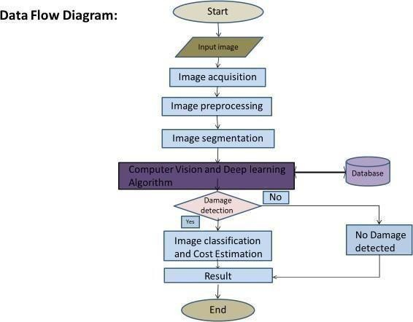Data Flow Diagram